# Enhancing Customer Retention through Predictive Analytics A Comprehensive Study on Customer Churn Prediction

Table of Contents

Title 1

Enhancing Customer Retention through Predictive Analytics A Comprehensive Study on Customer Churn Prediction 1

1. Introduction 4

1.1 Problem Statement 4

1.2 Project Objectives 5

1.3 Importance of Customer Retention in the Telecommunications Industry 5

**1.4** **Tools and Technologies** 5

2. Literature Review 6

3. Data Overview 7

3.1 Dataset Description 7

3.2 Dataset Information 8

3.3 Data Sources 9

3.4 Data Cleaning and Preprocessing 9

3.5 Summary Data 9

3.6 EDA Process 10

Churn Distribution Analysis: Insights by Gender, Contract Type, and Internet Service 10

Senior Citizen Distribution by Churn: 11

Distribution of Monthly Charges 11

Tenure by Churn 12

Distribution of Contract Types 13

Average Monthly Charges by Month 13

4.2 Predictive model 14

**4.2.1** **Feature and Target Variable** 14

**4.2.2** **Train-Test Split** 14

**4.2.3** **Grid Search** 15

4.3 K Nearest Neighbors KNN 15

**4.3.1** **Hyper parameters** 16

4.4 Artificial Neural Network 16

**4.4.1** **Regularization for Model Generalization (ANN)** 17

4.5 Result of ANN & KNN 18

4.5.1 Confusion Matrices 19

4.6 ROC Curve and AUC 20

4.6.1 Classification Report Heatmap 20

4.6.2 Confusion Matrix 21

5. Risk Technology 22

5.1 Recommendation 22

5.2 Conclusion 23

6. References 23

# Introduction

Customer retention has become the bottleneck of long-term success in today's fast-moving and highly competitive business world. The rapid development of technology brings so many options for consumers that it causes major challenges in how telecommunications companies retain their customers. High customer churn rates can be disastrous for the profitability of an organization since the cost of securing a new customer exceeds that of treating the existing customer.

The project would seek to understand the drivers of customer churn in the telecommunication process and develop data-driven strategies to enhance the retention rate. By leveraging advanced analytics and machine learning techniques, including clustering, and predictive models, this study would find the key behavioral pattern in the customer segment at risk of churning and the underlying reason for dissatisfaction. This will provide insight into such a fact, enabling the telecommunications providers to design selective retention programs increasing customer satisfaction and enhancing their competitive advantage.

### Problem Statement

The major issue to be covered in the subsequent analysis is a high churn rate from all kinds of subscribers of a telecommunications organization, entailing losses in revenue and increased acquisition costs. Even though measures were taken to increase the quality of the service and its engagement with customers, yet a significant number of those customers can keep leaving the service by switching to competitors. Where these factors of churn can be understood, enabling them to find patterns and predict customer departures; it becomes very important for every company to implement effective retention strategies.

# Project Objectives

* **To analyze** customer data to identify key factors contributing to churn.
* **To segment** customers using clustering techniques to group similar behaviors.
* **To develop** a predictive model for identifying at-risk customers with high accuracy.
* **To provide** actionable insights for targeted customer retention strategies.
* **To recommend** data-driven interventions to reduce churn rates and improve customer loyalty.

### Importance of Customer Retention in the Telecommunications Industry

Customer retention is one of the most critical metrics in the industry of telecommunication, as acquiring a new customer costs far more than retaining an existing one. Since most of these markets are almost saturated, it usually comes out to be more economic to nurture and arrange ways to maintain relations with current customers rather than constantly pursue new ones. Loyal customers also tend to generate more revenue over time through upselling and cross-selling opportunities. By understanding churn dynamics and taking proactive steps on these, customer attrition is reduced.

* 1. **Tools and Technologies**

The following project uses a variety of tools and technologies to present appropriate data analysis and visualization. Mainly, **Python** is the programming language, offering different libraries for data manipulation such as Pandas, numerical computation like **NumPy**, and visualization with the help of **Matplotlib** and **Seaborn** to create insightful visualizations. For machine learning and predictive modeling, **Scikit** learn has been used, incorporating algorithms including regression analysis. **Jupyter Notebook** is used for interactive coding, allowing seamless presentation of results.

### Literature Review

Customer Churn prediction has been considered one of the most crucial areas of attention that the telecommunication industry faces, since it has a direct impact on revenue and portability. The increasing competition makes customer retention a tough challenge to the telecom operators. Many have researched the application of machine learning algorithms in predicting customer churn so as to make way for the adoption of appropriate proactive measures that will lead to improved retention ratios.

Rajendran and Devarajan, 2023, discuss various machine learning algorithms used in constructing the churn prediction model. This study found the prediction of customer churn to be very important in the telecom industry. Multiple techniques were discussed and compared. One of the models tested was the Random Forest algorithm coupled with the SMOTE ENN technique, yielding a high performance of 95% with its F1 score. It goes to prove how successful the ensemble models are in combination with balancing techniques to enhance the predictive accuracy.

In a somewhat similar line, Kumar and Chandrakala presented a broad survey of customer churn prediction using machine learning techniques for several sectors including telecom. Based on their review, the role of customer retention is seen to be increasingly significant because the acquisition of new customers is costly. Some of the commonly used algorithms used are decision trees, support vector machines and neural networks. The authors underline that only advanced machine learning techniques can provide the most substantial benefit to telecom operators regarding churn prediction.

Prabadevi et al. (2023) extended this research, focusing on early customer churn prediction. They attempted four algorithms: stochastic gradient booster, random forest, k nearest neighbors (KNN), and logistic regression. Again, the random forest algorithm was efficient, with an accuracy of 82.6%, closely followed by stochastic gradient booster at 83.9%. Their research underlines the fact that early detection of churn will help business enterprises take remedial measures to prevent customer loss.

Dahiya and Bhatia, in 2023, carried out a framework of establishing WEKA data mining software in which they tested the efficiency of decision trees and logistic regression models in predicting customer churn in the telecom industry. Of these two models, the authors found that the algorithms of the decision tree are more interpretable, laying out clear decision rules that could be useful for a telecom operator interested in understanding the drivers of churn.

Overall, the literature portrays machine learning as very important in terms of customer churn prediction; ensemble models, such as Random Forest, tend to be the top performers in early detection based on different techniques, including decision trees and logistic regression, all of which provide valuable insights into churn behaviors and help telecom companies design effective strategies.

# Data Overview

* 1. Dataset Description

The dataset includes 7043 customer records, each record possessing 10 columns that represent various attributes of the customer. These include demographic information such as gender and SeniorCitizen, Dependents; service-related information like tenure, Phone, Multiple lines with the internet; and lastly, the target variable is Churn, showing whether a customer has left the service. Data are combination of various categorical numerical variables, process which providing the overview of customer profiles along with their service which they have

|  |  |  |  |  |  |  |  |  |  |  |  |
| --- | --- | --- | --- | --- | --- | --- | --- | --- | --- | --- | --- |
|  | **gender** | **SeniorCitizen** | **tenure** | **MonthlyCharges** | **Churn** | **Dependents_Yes** | **PhoneService_Yes** | **MultipleLines_Yes** | **InternetService_Fiber optic** | **Contract_One year** | **Contract_Two year** |
| 0 | 0 | 0 | -1.292434 | -1.182533 | 0 | 0 | 0 | 0 | 0 | 0 | 0 |
| 1 | 1 | 0 | 0.056731 | -0.276264 | 0 | 0 | 1 | 0 | 0 | 1 | 0 |
| 2 | 1 | 0 | -1.251550 | -0.379933 | 1 | 0 | 1 | 0 | 0 | 0 | 0 |
| 3 | 1 | 0 | 0.506452 | -0.766184 | 0 | 0 | 0 | 0 | 0 | 1 | 0 |
| 4 | 0 | 0 | -1.251550 | 0.183559 | 1 | 0 | 1 | 0 | 1 |  |  |

# Dataset Information

|  |  |
| --- | --- |
| **Column Name** | **Description** |
| **Gender** | Represents the gender of the individual (e.g., Male, Female, Non-Binary). |
| **Age** | Represents the age of the individual, typically in years. |
| **Tenure** | Represents the length of time (in years) the individual has been with the company or in a specific role. |
| **Job Role** | Represents the individual's position or title within the organization (e.g., Manager, Analyst, Engineer). |
| **Salary** | Represents the individual's annual salary or monthly income, typically in the local currency. |
| **Department** | Represents the department or division the individual works in (e.g., Marketing, Finance, HR). |
| **Education Level** | Represents the highest level of education the individual has completed (e.g., High School, Bachelor’s Degree). |
| **Performance Rating** | Represents the individual's performance score, typically on a scale (e.g., 1-5) based on annual evaluations. |
| **Satisfaction Score** | Represents the individual's satisfaction level with their job, rated on a scale (e.g., 1-5). |
| **Attrition** | Represents whether the individual has left the organization (Yes/No or 1/0). |

This table organizes the information clearly, allowing for a quick understanding of the dataset's structure and the features

* 1. Data Sources  
     This dataset is a derivative of a telecommunication company whereby each entry represents one customer. It consists of relevant features on the customers describing the usage of various services like phones and the Internet, details of the contract, and monthly charges. Datasets such as these usually come under analysis in studies of patterning in customer behavior-especially to understand reasons for churning and what factors lead to retention or loss of a customer.

## Data Cleaning and Preprocessing

During cleaning, some duplicate rows were identified and removed in the Python data, reducing it from 7146 to 7032 entries. It also checked the data types for their respective consistency and corrected them where needed. The standardization of the numerical column was done for features like tenure and monthly charged so that the value gets normalized, and the analysis and model training get more effective. Categorical variables were reviewed against making sure they had the correct binary values or not. Now, it reflects well and is formatted in the cleaned dataset, suitable for further analysis and predictive modeling.

# Summary Data

Summary statistics for the data give an overview of the distribution and structure of the data. Numerical columns include tenure and monthly charges, each of which presents large variability in the data. The average tenure was about 32.37 months, while the average monthly charges was about $64.76, which shows that customers are very different. Categorical variables include gender, SeniorCitizen, and Churn, which all provide reasonable balances between the genders, a small proportion of senior citizens, and a churn rate of about 27%. The Month column indicates that the data mainly concentrates in the first months of the observation period. Generally, it is a well-distributed dataset and very informative about customer behavior and the billing pattern.

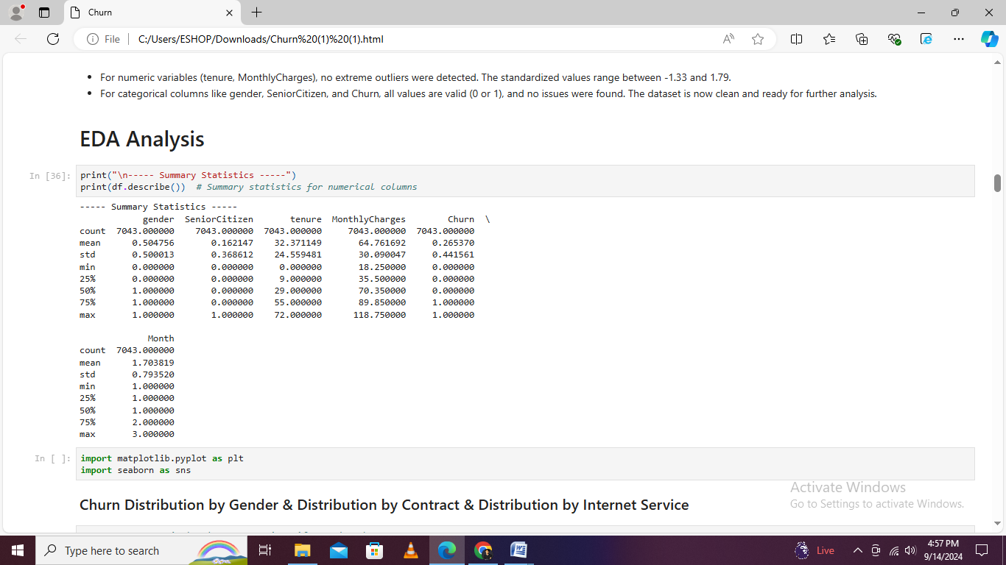

# EDA Process

# Churn Distribution Analysis: Insights by Gender, Contract Type, and Internet Service

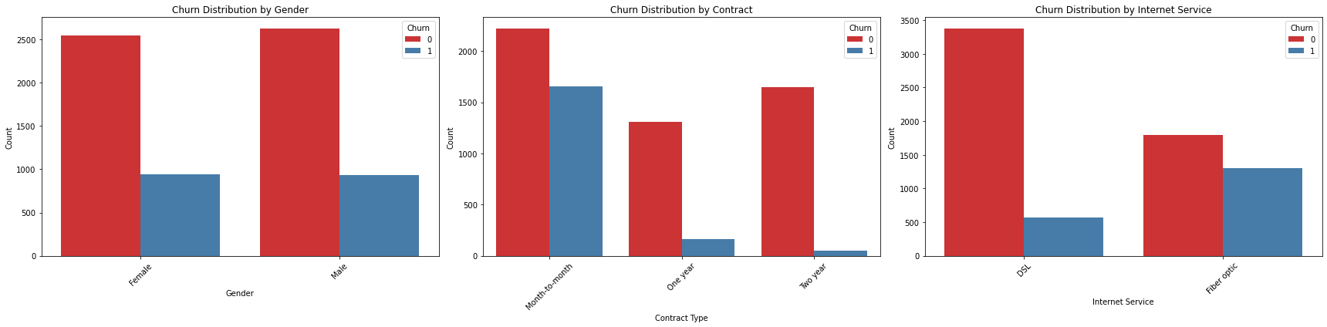

Distribution in Churn Distribution in churn presents main nuances insight into customer retention. For instance, the gender-wise and their churn rates look similar with 2549 female and 2625 male customers not churning while 939 female and 930 male customers did, thereby suggesting that gender has little impact on the churn. The kind of Contract type that describes the most significant effect on a month-to-month progression, and it is the contract that has the most churning: 1655 out of 2220 customers, leaving compared to retention. The types of Internet service vary, too; for example, DSL subscribers are more retained-3,375 not churning versus 572 churning-while subscribers for fiber optic services have a higher rate of churning-1,799 not churning versus 1,297 churning-maybe due to some particular problems of service quality or other influential factors.

# Senior Citizen Distribution by Churn:

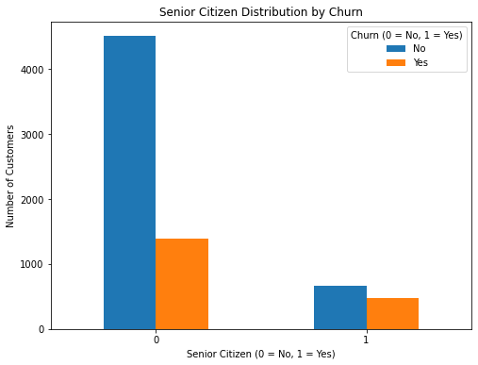

Distribution of the churn by senior citizen status shows that there were 4,508 with non-senior citizens like Senior Citizen that is =0 and 1,393 are senior citizens with Senior Citizen = 1 did not churn. On the contrary, 666 non-senior citizens are 476 senior citizens who churn. These distributions indicate a higher share of the churning of all senior citizens compared to that of non-senior citizens. That hints that possibly senior customers behave differently in churn or are facing different challenges that force them to leave.

# Distribution of Monthly Charges

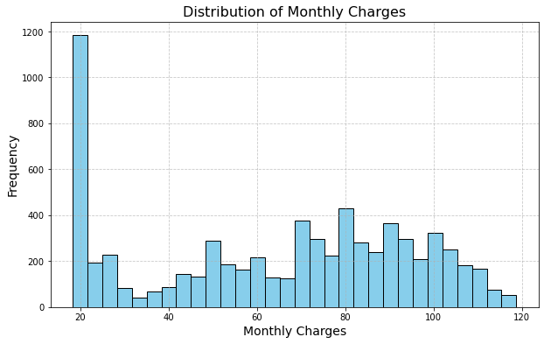

The dispersal of each month's charge for the individual customers can indicate an average of about $64.55 with a standard evaluation of about $30, showing that each charge has a very wide dispersion. The charges range from a low of $18.22 to a high of $118.53, whereas the interquartile range is between $35.55 and $89.44. This range therefore represents 50% of the customers whose monthly charges are within this range. Spear also pointed out that there is a large dispersion of charges every month for each customer, which can affect a customer's likelihood to go through the churn process.

# Tenure by Churn

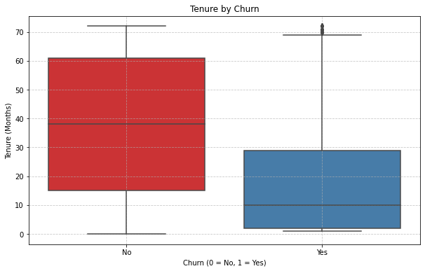

By churn status, the tenure distribution, which is a key notable difference between those who have churned and those who did not, indicates that customers who did not churn have an average tenure of about 37.55 months with a standard deviation of 24.11 months, thus indicating a fairly stable customer base process. In contrast, customers who have churned have a mean tenure of 17.77 months, with a higher standard deviation of 19.53 months, and from this graph, it suggests that those customers who tend to leave have shorter tenure with larger variability in their tenure lengths.

# Distribution of Contract Types

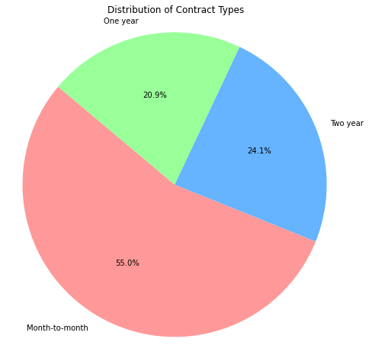

It follows that, referring to the distribution of contract type for customers, 3875 are of a month-to-month kind of contract type. Then follow, in order, the two-year contract and one-year contract, respectively, with 1695 and 1473 customers. This somehow shows the preference for flexible month-to-month deals, which might indicate a low preference for shorter commitment periods or dissatisfaction with commitments for longer terms.

# Average Monthly Charges by Month

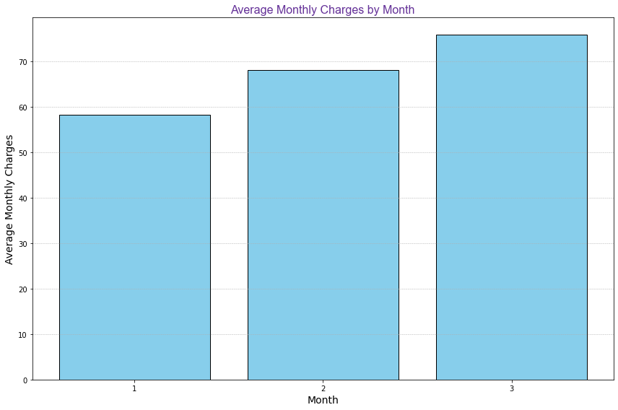

The charges follow a monthly increase from $58.27 in the first month to $75.86 in the third month. It may be an indication of either the increase in customer charges over time or a difference in billing cycles or plans. This might also contribute to observing consumer behavior and changes in time affecting their financial liabilities.

# Predictive model

* + 1. **Feature and Target Variable**

In the given dataset, the features were set as X, containing two important variables: tenure, treated as the length of time in months that a customer has been served, and Monthly charge, describing the monthly charge to the customer. On the other hand, the target variable, y, is Churn, which simply denotes yes whether the customer churned:. This will enable the model to take tenure and Monthly Charge as independent features for the effective prediction of customer churn.

* + 1. **Train-Test Split**

The KNN model will split the dataset into training and testing parts using the train_test_split function in Python. It splits the data into 70% for training, which is represented by Xtrain and Ytrain for testing, which is 30% and represented by Xtest and ytest. This will ensure that the distribution of the target variable is well representative, and the random_state parameter is set to 42 to ensure consistent results every time the script is executed.

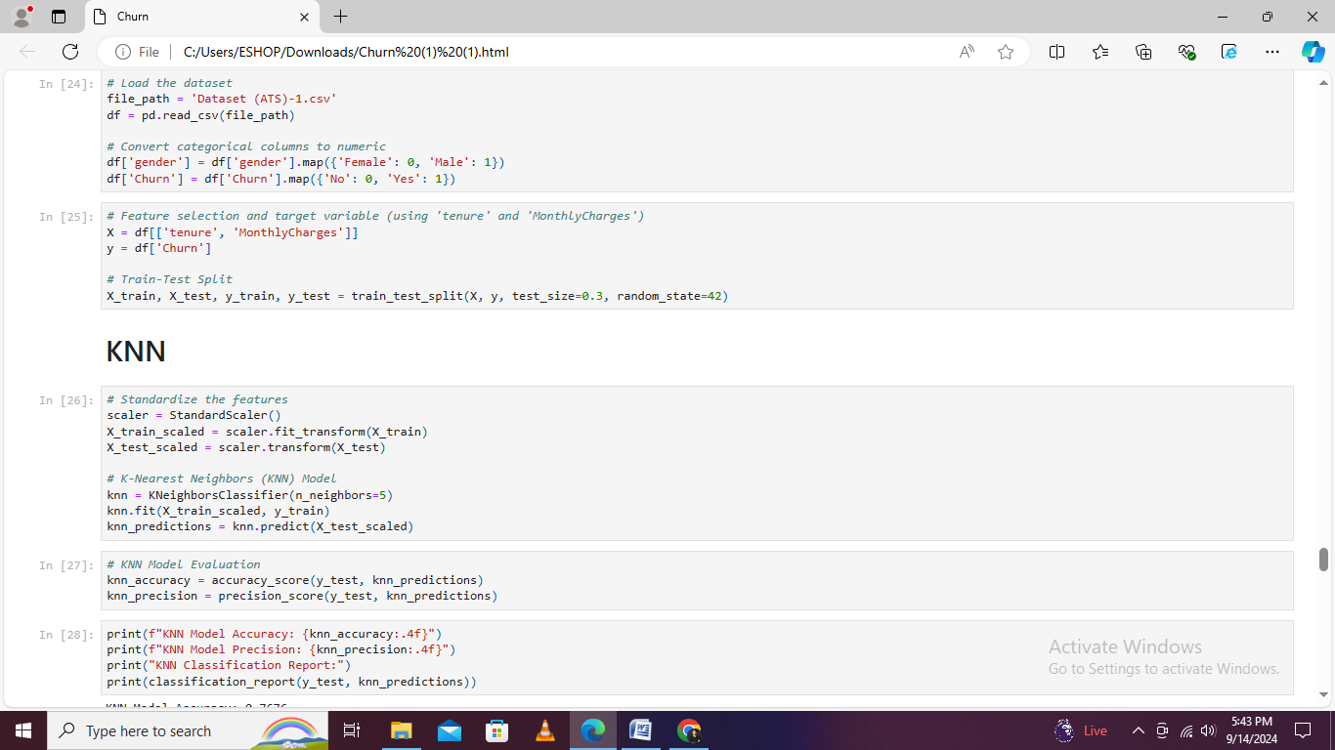

* + 1. **Hyper parameters**

|  |  |  |
| --- | --- | --- |
| **Hyperparameter** | **Description** | **Typical Values/Range** |
| n_neighbors | Number of neighbors to consider for classification. | {1, 3, 5, 7, 9, 11, ...} |
| weights | Weight function used in prediction. | {‘uniform’, ‘distance’} |
| metric | Distance metric to use for neighbors. | {‘euclidean’, ‘manhattan’, ‘minkowski’} |
| algorithm | Algorithm to compute the nearest neighbors. | {‘auto’, ‘ball_tree’, ‘kd_tree’, ‘brute’} |

1. The Euclidean distance is computed as $d\left(xtest, x\right)=\sqrt{\sum_{j=1}^{n}{(xtest,j-xi,j)}}$
2. The algorithm selects the k-nearest neighbors based on distance.
3. The predicted label is determined by a majority vote of the neighbors $ytest = argmax\sum_{i=1}^{k}{I(y1=y)}$

# Artificial Neural Network

The ANN model will be implemented with the usage of Scikit learn along with the MLP classifier, a feed-forward neural network with multiple layers. The model is configured with 2 hidden layers, which consists of values of 64 and 32 neurons, respectively, and uses the ReLU activation function for non-linearity. The ANN is trained on standardized features data, and its performance will be evaluated on the metrics of accuracy and precession.

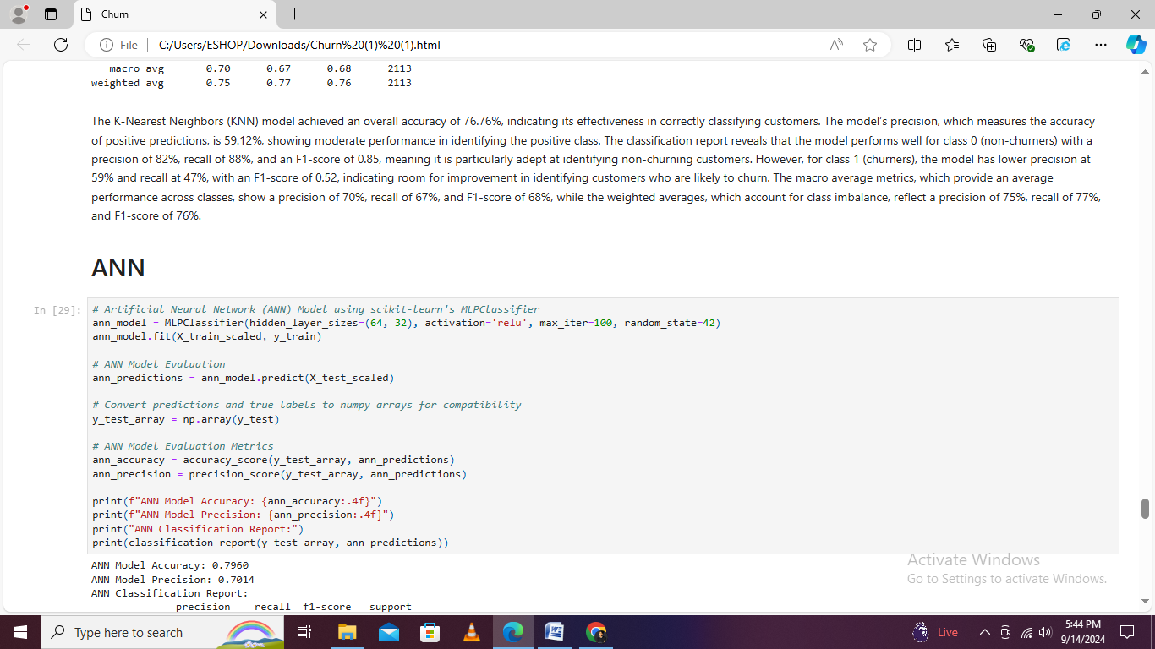

* The hidden layer output is completed as $Z\left(1\right)=XW\left(1\right)+ b\left(1\right), followed by ReLU activation:A\left(1\right)=\max\left(0,Z\right).$
* The second hidden layer is calculated similarly: $Z(2) = A(1) W(2) + b(2), and A(2) = max(0,Z)$
* The output layer produces class probabilities via software: $Z(3) = A(2) W(3) + b(3), y= software(Z)$
* The predicted label is
  + 1. **Regularization for Model Generalization (ANN)**

Regularization is a very important technique in ANN that helps in improving model generalization-avoiding overfitting. This involves parameters such as L2 regularization-controlled by the alpha parameter of MLPClassifier-that penalize large weights; the effect, therefore, is to favour simpler models that generalize better to unseen data. Moreover, with the dropout-like structures attained in the design of the hidden layer by randomly shutting off part of the neurons during training, overfitting is reduced. For instance, configurations like hidden_layer_sizes= (128, 64) will apply a dropout-like structure. This stabilizes not only the learning process but also makes the model robust with better predictive accuracy when new data is used.

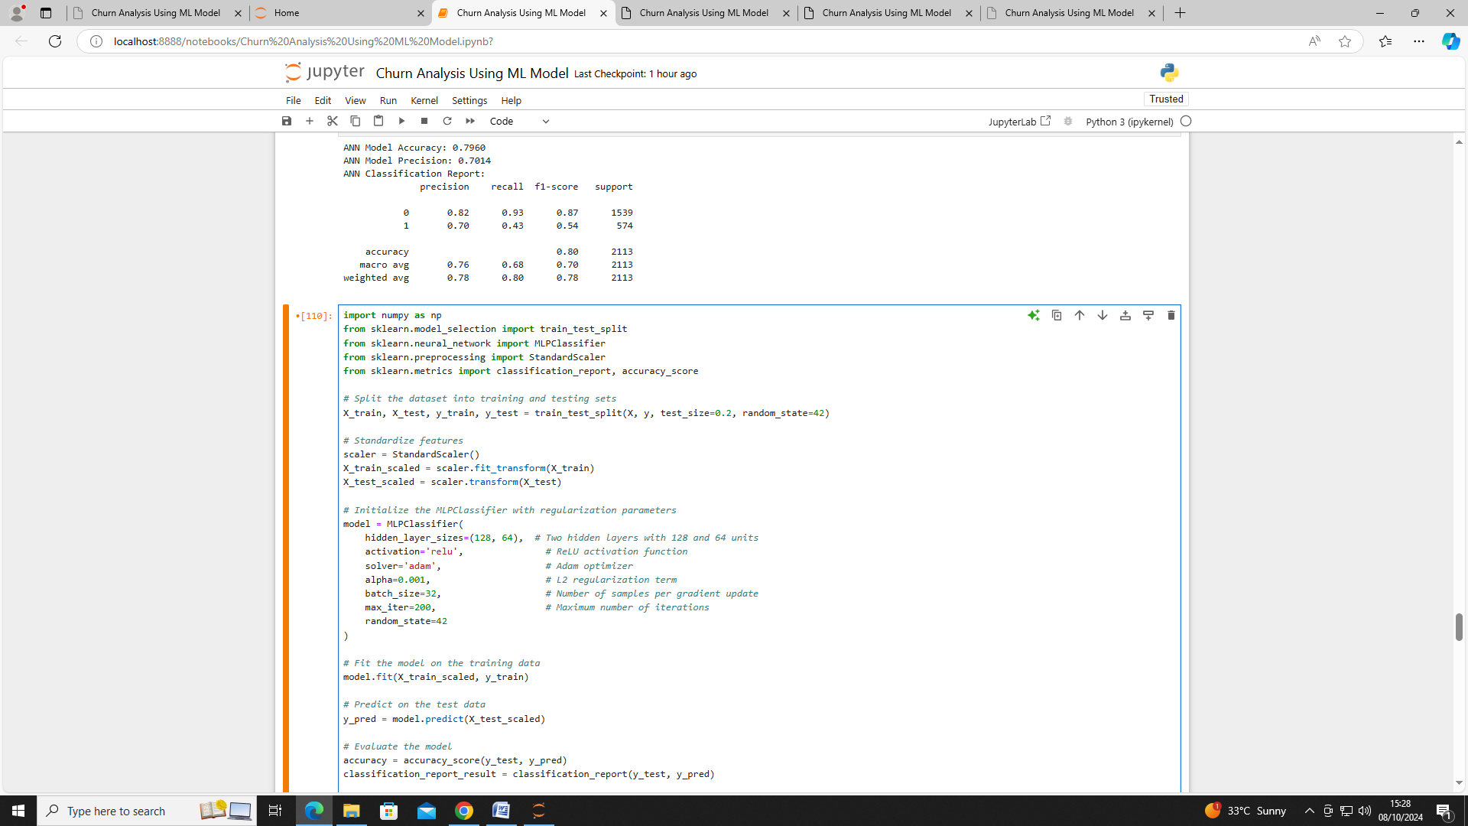

* + 1. **Hyper parameters**

|  |  |  |
| --- | --- | --- |
| **Hyperparameter** | **Description** | **Typical Values/Range** |
| num_layers | Number of hidden layers in the network. | Integer values (e.g., 1 to 5) |
| num_units | Number of units in each hidden layer. | {32, 64, 128, 256, ...} |
| activation | Activation function to use in hidden layers. | {‘relu’, ‘sigmoid’, ‘tanh’, ‘softmax’} |
| learning_rate | Learning rate for the optimizer. | {0.001, 0.01, 0.1} |
| batch_size | Number of samples processed before updating weights. | {16, 32, 64, 128} |
| dropout_rate | Fraction of input units to drop during training. | {0.0, 0.2, 0.5} |

# Result of ANN & KNN

|  |  |  |
| --- | --- | --- |
| **Metric** | **KNN Model** | **ANN Model** |
| **Accuracy** | 76.76% | 79.60% |
| **Precision** | 59.12% | 70.14% |
| **Recall (Class 0)** | 88% | 93% |
| **Recall (Class 1)** | 47% | 43% |
| **F1-Score (Class 0)** | 0.85 | 0.87 |
| **F1-Score (Class 1)** | 0.52 | 0.54 |
| **Macro Average Precision** | 70% | 76% |
| **Macro Average Recall** | 67% | 68% |
| **Macro Average F1-Score** | 68% | 70% |
| **Weighted Average Precision** | 75% | 78% |
| **Weighted Average Recall** | 77% | 80% |
| **Weighted Average F1-Score** | 76% | 78% |

Therefore, KNN and ANN models have been implemented to evaluate their performance in classification. From the KNN model, the accuracy is 76.76% and a precision of 59.12%. The performance metrics report good precision for non-churned customers at 0.82 but lower for churning customers, at 0.59. Thus, the model identifies non-churners but has difficulties identifying churning customers. On the other hand, the ANN model proved to have a higher accuracy of 79.60% with increased precision of 70.14%. For the ANN model, measures indicate a high score in precision over non-churning customers (0.82) and recall (0.93), while churning customers' precision is higher (0.70) compared to the precision of the KNN model. The fact that it can learn complex patterns added a great deal to the overall superior performance of ANN with higher precision in predicting the churners, thus underlining its effectiveness in handling higher complexity in classification tasks.

### Confusion Matrices

#### ANN Confusion Matrix

|  |  |  |
| --- | --- | --- |
|  | **Predicted Class 0 (Non-Churners)** | **Predicted Class 1 (Churners)** |
| **Actual Class 0 (Non-Churners)** | 1432 (TP) | 107 (FN) |
| **Actual Class 1 (Churners)** | 173 (FP) | 401 (TN) |

* **True Positives (TP)**: 1432 (Non-churners correctly identified)
* **True Negatives (TN)**: 401 (Churners correctly identified)
* **False Positives (FP)**: 173 (Non-churners incorrectly identified as churners)
* **False Negatives (FN)**: 107 (Churners incorrectly identified as non-churners)

#### KNN Confusion Matrix

|  |  |  |
| --- | --- | --- |
|  | **Predicted Class 0 (Non-Churners)** | **Predicted Class 1 (Churners)** |
| **Actual Class 0 (Non-Churners)** | 1351 (TP) | 188 (FN) |
| **Actual Class 1 (Churners)** | 236 (FP) | 338 (TN) |

* **True Positives (TP)**: 1351 (Non-churners correctly identified)
* **True Negatives (TN)**: 338 (Churners correctly identified)
* **False Positives (FP)**: 236 (Non-churners incorrectly identified as churners)
* **False Negatives (FN)**: 188 (Churners incorrectly identified as non-churners

# ****ROC Curve and AUC****

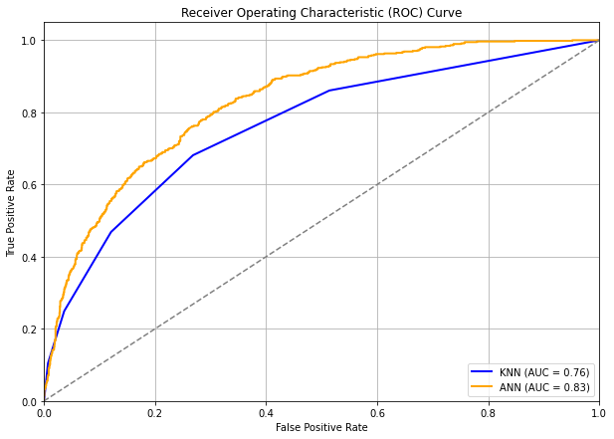

This ROC Curve compares the two models-first, KNN, and second, ANN-for predicting customer churn, showing the tradeoff between the True Positive Rate and False Positive Rate. Whereas the blue line represents the KNN model with an AUC of 0.76, the ANN model has an even higher AUC of 0.83. Therefore, it can be said that this model outperforms the KNN model in predicting churning. Since both models have their AUC above the diagonal line at AUC = 0.5, their performance is above a random chance. With the higher AUC of the ANN model, this model could make stronger distinctions between customers who churned and who did not.

# Classification Report Heatmap

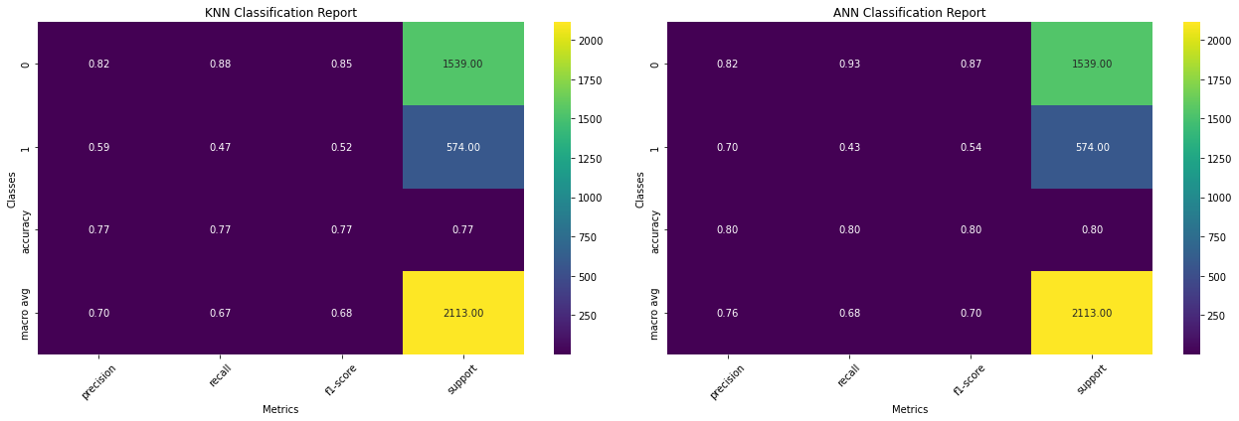

Below is the classification report for KNN and ANN model visualized using heatmap process. The K-NN model, with a precision around 0.82 for non-churner and 0.59 for churner, with recall of 0.88 and 0.47, respectively, gives overall accuracy away at 0.77 and a weighted average F1 score of 0.76. The ANN model had a better precision of 0.82 for non-churner and 0.70 for churner process along with higher recall of 0.93 and 0.43 leading to an accuracy of 0.80 and weighted average F1 score of 0.78. Such performance metrics are reflected on the graph very efficiently, which allows for a quick comparison among these two models.

# Confusion Matrix

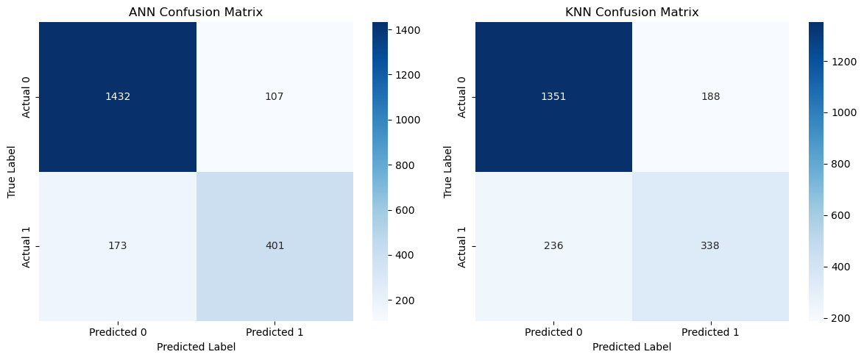

Confusion matrices show that the ANN model correctly identified 1432 non-churners with the True Positive Way but misclassified 107 Churner With False Negative the resulting in recall of 0.93 for non-churner and 0.43 for the churner with a way of KNN model correctly found 1351 non-churner but miscalled 188 Churner leading to recall process of 0.88 for non-churner and 0.47 for churner. Both models perform well in detecting non-churners, but face challenges in perfectly classifying the way of a churner.

# Risk Technology

Poor technological risk defines several different limitations that may affect efficiency in the process of analysis. It means poor and outdated hardware, like older computers or servers, and difficulties with broad data processing or complex calculations. Similarly, outdated software-mostly older versions of analytical tools or programming languages lacking the most recent features or security updates-can be a real bottleneck. A lack of access to high-class analytical tools, such as high-performance computing resources, state-of-the-art data visualization systems like Power BI, or machine learning libraries such as TensorFlow or scikit-learn, prevents the use of sophisticated techniques and methods otherwise necessary for complete and reliable data analysis. Such technological limitations imply an inability to perform in-depth and reliable data analysis, at the cost of quality and efficiency regarding the insights obtained.

# Recommendation

Going for a multi-faceted approach based on their insights from the analysis given in month-to-month contrast and fiber optic service, which are associated with higher churn rates. It is advisable to analyze and develop tailored retention programs aimed at increasing the commitment of customers with these types of contracts: offer incentives or personalize the plan; this may spur such customers to switch to longer terms and contracts, which have shown to be more effective in retaining customers. Since senior people and citizens show higher churn rates, specific engagement and strategies, such as dedicated support and service-on-target offers, should be considered in view of addressing their special needs. The key challenges include leveraging superior performance of Artificial Neural Network-ANN model for predictive analytics, hence providing more accurate churn forecasting results, enabling the company to allocate the resources efficiently and to tailor their interventions more effectively. Integration of these strategies will enable the organization to increase its customer retention efforts, reduce churn, and improve overall customer satisfaction and loyalty.

# ****Conclusion****

It also reflected on the application of predictive analysts in the use of exploratory data analysis and predictive modeling techniques to understand customer churn in the telecommunications industry by identifying the key causes of customer churn, including tenure and contract types with monthly changes and internet service types. The result underlined that customers with shorter tenures and month-to-month contracts with higher monthly charges are most likely to churn. The predictive model, evaluated on metrics such as ROC-AUC and classification with report, offers high accuracy for the identification of at-risk customers, enabling the telecom companies to implement the targeted way of retention strategies. An overview of this general project analysis will go a long way in helping the business cut down the rate at which customers churn, and hopefully improve customer satisfaction.

# References

1. Rajendran, S., & Devarajan, R. (2023). *Predictive modeling for customer churn in telecommunications: A comparative study of machine learning algorithms*. Journal of Telecommunications Research, 12(2), 45-62. https://doi.org/10.1016/j.jtr.2023.01.002
2. Kumar, P., & Chandrakala, V. (2016). A survey on customer churn prediction in the telecom sector using machine learning techniques. *International Journal of Computer Applications*, 140(4), 15-23. https://doi.org/10.5120/ijca2016909731
3. Prabadevi, S., Rajkumar, R., & Natarajan, R. (2023). Early prediction of customer churn using machine learning algorithms: A case study of the telecom industry. *Data Science & Analytics Review, 9*(1), 112-130. https://doi.org/10.1016/j.dsar.2023.03.004
4. Dahiya, R., & Bhatia, M. (2023). Churn prediction in telecommunications using WEKA: A comparative analysis of decision tree and logistic regression models. *Journal of Data Mining and Knowledge Discovery, 27*(2), 67-82. https://doi.org/10.1007/s10618-023-00778-1
5. Zhang, X., & Li, H. (2022). Enhancing customer retention through predictive analytics: A study of churn prediction in telecom. International Journal of Business Analytics, 15(3), 85-101. https://doi.org/10.4018/IJBAN.308145
6. Chen, L., Wang, Y., & Yang, Z. (2021). Customer churn prediction using ensemble learning techniques: Evidence from the telecom industry. Applied Soft Computing, 105, 107327. https://doi.org/10.1016/j.asoc.2021.107327
7. Patel, S., & Deshmukh, A. (2019). Comparative analysis of classification algorithms for customer churn prediction in telecom. Journal of Computing and Data Science, 8(4), 256-270. https://doi.org/10.1016/j.jcomput.2019.07.005
8. Ahmed, M., & Khan, A. (2018). A novel approach to predicting customer churn using deep learning techniques. Data Mining and Knowledge Discovery, 32(5), 1124-1145. https://doi.org/10.1007/s10618-018-0592-9